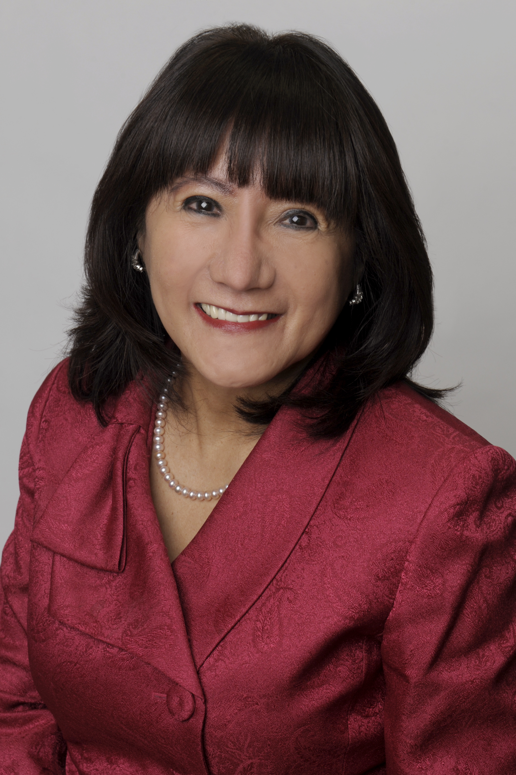

**Luz del Rosario**  
Chair of the Board of Trustees Trustee, Mississauga  
Wards 6 & 11  
(416) 528-6447  
luz.delrosario@dpcdsb.org

**  
  
AGENDAS AND MINUTES**[**Board and Committee Meetings**](https://www.dpcdsb.org/news/board-meetings)



**Dufferin-Peel Catholic District School Board**  
40 Matheson Blvd. W.  
Mississauga, ON L5R 1C5  
905-890-1221  
[dpcdsb.org](https://dpcdsborg-my.sharepoint.com/personal/50212_educ_dpcdsb_org/Documents/DPCDSB%20Visual%20Branding%20and%20Templates/Letterheads%20and%20Memo%20-%20Editable%20Templates/dpcdsb.org)

[](https://www.facebook.com/DPCDSBSchools/) [](https://twitter.com/DPCDSBSchools) [](https://www.instagram.com/dpcdsb.schools)

Our DPCDSB Mission: Disciples of Christ, nurturing mind, body and soul to the fullness of life.  
Our DPCDSB Vision: Changing the world through Catholic education.

**October 2024**

This month’s virtue of EMPATHYreminds us of our responsibility to uphold the dignity of all persons and care for one another. As part of our Catholic identity, we believe the cross is the ultimate sign of compassion and forgiveness. Empathy is integral to supporting our students in their academic learning and in nurturing their relationship with Christ.

**October 2024 – Month of the Holy Rosary and of the Missions** – His Grace Most Reverend Francis Leo, Metropolitan Archbishop of Toronto, reminds us that October is devoted to Our Lady by means of the prayer of the holy Rosary and the Church’s missionary activity in the world today.

**Student Transportation Update -** School Bus Safety Week is October 21-25. Parents/guardians are encouraged to visit the [STOPR website](https://www.stopr.ca/) to view school bus safety videos with their children. School Bus Driver Appreciation Day is on Wednesday October 23. Our school bus drivers are highly skilled professionals, and we thank them for the important work they do to ensure our students get to and from school safely every day.

**“ I was hungry and you gave me food. I was thirsty and you gave me drink. I was a stranger and you welcomed me. “**

**- *Mathew 25:35***

**DPCDSB Treasury Report** – *Ontario Regulation (O. Reg.) 41/10 - Board Borrowing, Investing and Other Financial Matters*, under the *Education Act*, requires all school boards to bring forward investment information to the Board of Trustees. During the 2023-2024 fiscal year, DPCDSB continued to borrow money to meet operating expenditure obligations. Borrowing was necessary as a result of the deficit financial position of the DPCDSB, no accumulated surplus funds and timing differences between our collection of revenues from municipalities and the province, and expenditure payment schedules. DPCDSB has borrowing resolutions approved by the Board of Trustees for operating and capital needs, as follows:

* $150 million – Temporary Borrowing Resolution related to operating needs.
* $65 million – Temporary Borrowing Resolution related to capital needs.

The Ministry of Education has been working with DPCDSB to address cash management challenges, however, the primary tool to assist the board is to front-load Core Education (Core Ed) Grant payments. By yearend, this results in less transfer payments and pressure on temporary borrowing as the front-loaded amounts must be recovered before the end of August in any given year. To assist with current cash flow pressures, the September 2024 payment was advanced on September 5, 2024. The next tax instalment from municipalities was scheduled to be received by September 30, 2024.

**2024-2025 MYSP** – The 2023-2027 Multi-Year Strategic Plan (MYSP) informs the direction of system operations and is fundamental to developing educational programs for students. In 2023-2024, our MYSP was shared across the system and externally with all DPCDSB partners, members, and stakeholders. As per the Ministry of Education requirements, the DPCDSB released the Fall MYSP Evaluation Survey last month to help monitor MYSP values and gather feedback. The survey closes on October 31, 2024. [Learn more](https://www3.dpcdsb.org/Documents/COMMUNITY%20INFORMATION%20BULLETIN%20MYSP%20Survey%20September%2016%202024.pdf).

**Homework and Curriculum Expectations** – As a faith-based school system, the DPCDSB approaches all issues from a Catholic world view that recognizes the importance of family time, and honours the bonds between school, family, and parish. Homework, which plays an important role in the relationship between the school and the family, is defined by the Ministry of Education in *Growing Success* as “*work that students do at home to practice skills, consolidate knowledge and skills, and/or prepare for the next class.”* Given the importance of balancing learning and home/family life, the DPCDSB has a homework policy to support students as they balance their personal and school lives. To ensure that the process for implementing homework is reflective of DPCDSB values and practices, Policy 10.00: *Homework – Kindergarten to Grade 12, Including Students with Modified Curriculum Expectations and Alternative Curriculum Expectations* has been updated. Parents/guardians who have concerns with homework expectations for their child(ren) should contact their child(ren)’s teacher(s) and/or school administrators.

There is no requirement that homework be assigned daily for students. When homework is assigned, it must be directly related to *what the student is learning in class* and has the following characteristics:

* is meaningful and relevant;
* is purposefully planned to avoid student overload;
* is clearly articulated by the teacher and understood by students;
* is differentiated, as appropriate, to meet student learning needs;
* is reviewed in a timely manner.

Our school administrators support the value of homework by:

* ensuring school-wide understanding and consistent implementation of homework procedures;
* coordinating school-wide resources and practice to support homework;
* providing information to parents about homework procedures and how to access community supports.

**Eco Schools Certifications –** *EcoSchools Canada* (formerly Ontario EcoSchools) was created by a consortium of education stakeholders to address environmental issues in the formal education system. The Toronto and Region Conservation Authority (TRCA) has been engaged by the Region of Peel to assist with the implementation of the *EcoSchools Program* in Peel schools. The *Peel EcoSchools Project* is structured as a joint initiative with TRCA, EcoSchools Canada, Region of Peel, DPCDSB and the Peel District School Board. For eleven years in a row, 100 percent of our DPCDSB schools have attained Eco Schools certification status. DPCDSB accomplishments and commitments to stewardship and sustainable practices have been achieved through platinum, gold, silver and bronze certifications*.* The collaborative efforts of Board staff, educators, administrators and school Eco-Teams have been instrumental in the success of environmental initiatives geared to conserving our natural resources and reducing our carbon footprint on the planet. Congratulations to all of our schools who continue to work hard in achieving and maintaining the platinum status.

**Board-wide 2023-2024 Key Statistics from Eco Schools Certification Applications**

* 131 DPCDSB schools participated in Earth Day activities;
* 133 DPCDSB schools participated in The Great Gulp;
* 118 DPCDSB schools participated in Earth Hour;
* 127 DPCDSB schools participated in National Sweater Day;
* 96 DPCDSB schools organized and completed Waste-Free Lunch campaigns;
* 170 various planting actions were completed by DPCDSB schools;
* 2,584 total Eco Schools actions were completed across DPCDSB;
* 3,010 students were part of their schools’ Eco Clubs.

**Extended Excursions** – DPCDSB has a rich tradition of offering students the opportunity to participate in extended excursions as an enhancement to their regular program of study. Local schools offer these through educational travel, social justice, and special programs. Proposals for consideration are submitted by schools including the rationale, documentation, itinerary, budget, and approved Tour Operator information. Our Catholic faith is reflected in all itineraries including an expectation that all students and supervisors attend a Catholic Mass on all Sundays during the trip.

Schools do not sign any contracts, deposit student/parent funds, or make any form of commitment to students and families until the excursion is approved by the Associate Director of Instructional Services, the Board’s Legal Department and is presented to the Board of Trustees for receipt. All extended excursions should take place during Christmas, March break, or summer breaks, with no more than two (2) instructional days being missed, although exceptions may apply for special circumstances. Appropriate steps are in place to ensure students have opportunities to make up assignments and/or assessments during the missed instructional day(s). Appropriate levels of supervision are in place in keeping with the Board’s policies. A communication plan must be made available to parents. All participants are expected to purchase cancellation insurance, and medical coverage/insurance appropriate to the excursion is required. The DPCDSB has a duty to provide Catholic conditions for the safety, well-being and learning of all within our community. Staff will continue to monitor threats associated with international travel as we move forward with future extended excursion trips.

**Korean Delegation –** On Sept. 26th, St. Marcellinus Catholic Secondary School hosted delegates from the Gyeonggi Provincial Office of Education, one of the Provincial Ministries in South Korea. The Korean Ministry has sent this delegation overseas to learn about Ontario Ministry/Board policies and strategies how to improve its public educational system, as the dropout rate in Korean public system is getting higher. After visiting St. Marcellinus, they also visited St. Herbert Catholic Elementary School. Below are some of the pictures I took during St. Marcellinus’ visit:

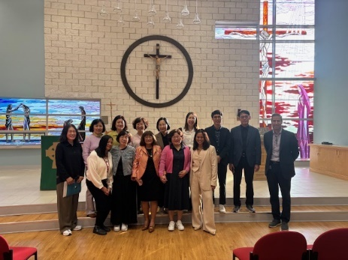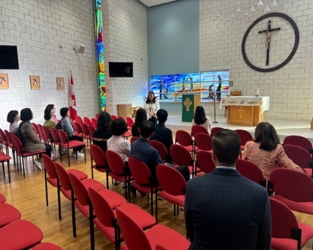 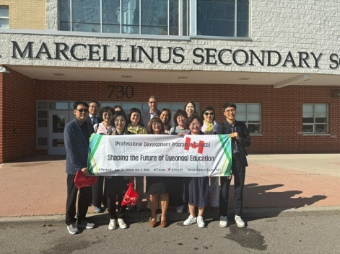

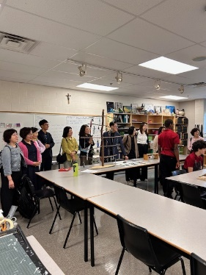 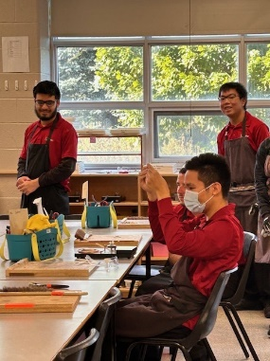 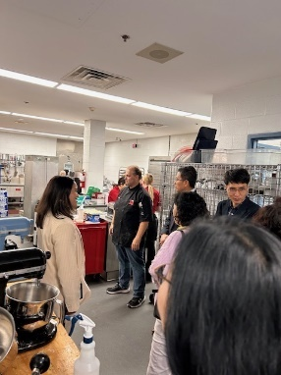 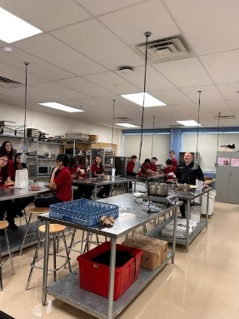

Thank you to the principals, vice-principal and teachers who took the time to take the delegates to the classrooms and spoke briefly of the programs our schools offer. The delegates were very impressed of the different programs and had asked many questions to the teachers and principal.

I am proud to serve as your DPCDSB Catholic School Trustee. Parents and guardians are always welcome to contact their elected School Board Trustee regarding system-level concerns or questions about publicly funded Catholic education. Please do not hesitate to reach out to the administrative and education teams at your child(ren)’s school, should you require more information and support with regards to immediate issues in your child/ren’s education.

Thank you for choosing a Catholic education for your child/ren. May God bless you always.

Wishing our students, families, and staff a blessed time of worship and Thanksgiving with loved ones and friends.



Take care and God bless you always.

**Luz del Rosario**

**Luz del Rosario**Chair of the Board of Trustees  
Trustee, Mississauga Wards 6 & 11